1. Draw a sequence diagram for this code.
class Report:
def sum(self, courselist: Iterator[Course]) -> int:
total = 0
course = next(courselist)
credits = course.credits
total += credits
course = next(courselist)
credits = course.credits
total += credits
return total
Even though the 2 course objects are different, in the Squence diagram you can show the call to credits as calling the same unnamed object (box).
course.credits is a property. Show it as a method call.
Write the call name on the "found" message.
total += credits is not a method call, but its an important operation. Show it in an oval next to the activation at the point where it occurs. Some people draw the oval on top of the activation box.

2. For the code on the midterm exam (GUI that creates a CourseList), draw a sequence diagram of what happens when the user clicks "Enroll".
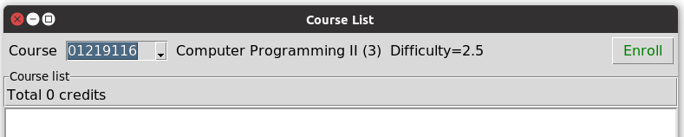

Suppose that CourseUI has these members:
courselist - reference to a CourseList object
handle_button - event handler for button click event
combobox_selection - a tk.StringVar tied to the selection in the combobox.
The participants in the Sequence Diagram are: Button, CourseUI, a StringVar, and courselist.
The object "names" are unimportant, so you can omit them.
2. Draw a sequence diagram of what happens when sale.computeVat(m) is invoked with a Money reference m. Show the call to "computeVat(m)" as the "found" message.
class Sale:
def computeVat(Money money) -> Money:
amount = money.value
currency = money.currency
# return the tax as a new money object
Money tax = new Money(amount * 0.07, currency)
return tax

3. Fill in the blanks to show how to use an Iterator to sum the value of a Collection of coins.
public double sum( Collection<Coin> coins ) {
______________ iterator = coins._______________;
double sum = 0.0;
while ( ___________________ ) {
sum += __________. ____________ . _________________ ;
}
return sum;
}
4. Draw a UML sequence diagram for the previous exercise. Use one Coin object to represent the coins in the loop (even though in fact they would be different). Note that in a sequence diagram you don't have to show operations performed inside a method (like sum = sum + 1) but you can show them by writing the operation inside an oval next to the activation box.
Here is some code for a university Course Management application.
public class Registrar { /* a Singleton class */
private static Registrar instance = new Registrar();
private CourseCatalog catalog;
private Registrar( ) {
// code to initialize registrar and course catalog
}
public static Registrar getInstance( ) {
return instance;
}
public CourseCatalog getCourseCatalog( ) {
return catalog;
}
public List<Enrollment> getEnrollment(String studentId) {
// return all Enrollments for student with given studentId
}
}
public class CourseCatalog {
private List<Course> courses;
public Course getCourse(String courseId) {
// code to find course in catalog is not shown
Course course = . . .
return course;
}
}
public class Course {
private String courseId;
private int credits;
private String name;
public String getName() { return name; }
public int credits( ) { return credits; }
public String getCourseId() { return courseId; }
}
5. Draw a UML class diagram showing the relationships between classes.
6. Write Java code to get the name and number of credits for course 01204499. Be sure to test whether this course really exists!

7. Draw a Sequence Diagram of your code from previous problem.

